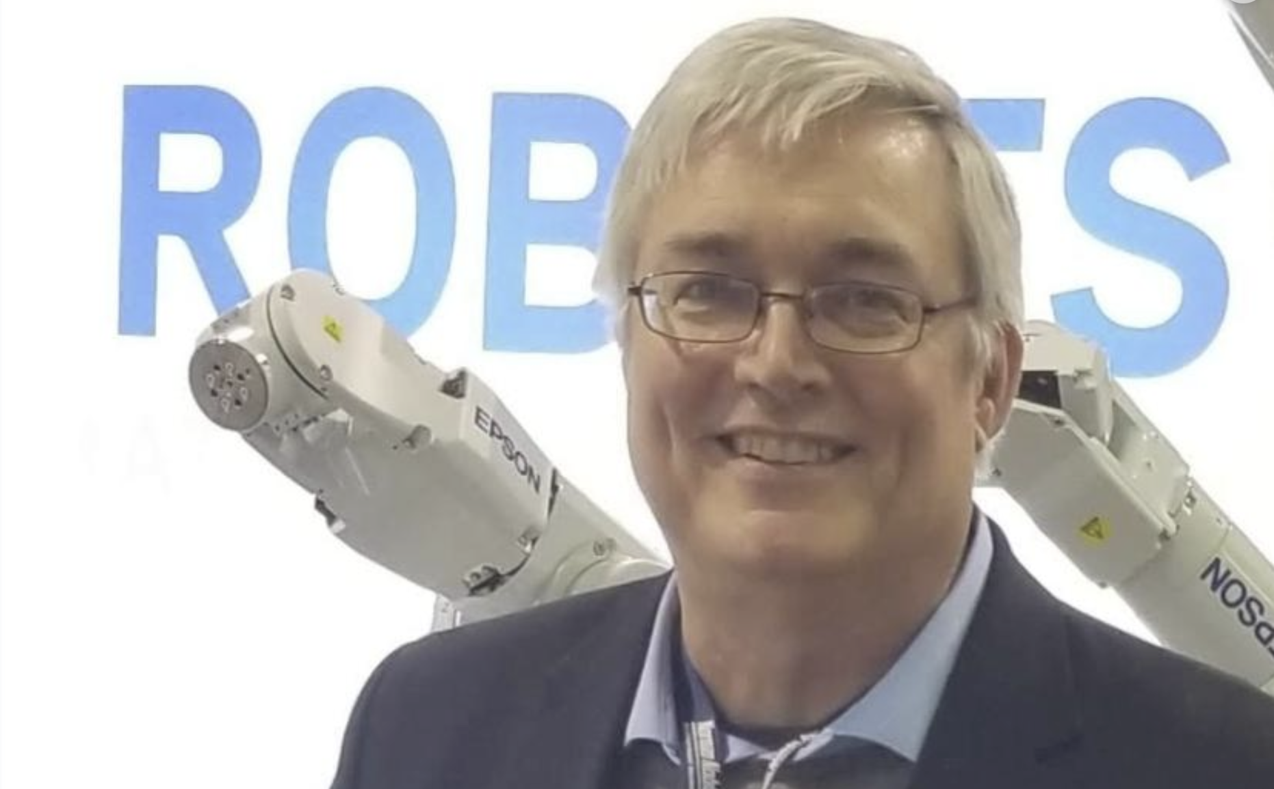

Join us Thursday, October 17 at 5 PM for networking and a presentation on “How to identify Technology Careers & Network Purposefully with Cornell Alumni”

Networking with Everette 5:00-5:20pm and Presentation from 5:20-6: 20pm

Things you will learn:

    1) Practical approaches to identifying evolving technologies where jobs will be for the next decade even during economic turmoil

    2) How to expand your search results in LinkedIn for making meaningful connections in your target industry

    3) Using Cornell resources to add to your success network development – ie finding alumni who will return a text or email or call

Everette Phillips has decades of experience in the field of robotics and advanced manufacturing technologies. He has spent time in many of the worlds most advanced production facilities from making inkjet cartridges at HP to battery production at Tesla and will share insights into the state of Exponential Technologies like Robotics and AI today and future trends in areas likely to offer meaningful career now and in the future. Everette studied Bioengineering in Riley Robb Hall and created the LinkedIn Group called The Riley Robb Connection to help students and alumni network and share. Everette also holds an MBA from the UCLA Anderson School